Contents
Contents 1
Abstract 2
1. Introduction 2
2. Design and Implementation of the FLC 2
3. Design Justification 6
4. Analysis of Controller Performance 6
5. Hybrid Systems – FLCs and Other Computational Intelligence Techniques 8
6. References 8

ABSTRACT
The world of mobile robotic navigation has been an open and tricky problem since the 1980s. Robots require navigation in unfamiliar and energetic environments. They have also become a huge focus in manufacturing companies for material handling and other component coupling and installation. This area of research has been taken to homes wherein robots are built as home assistant (this involves helping in cleaning, washing and clearing the house to put in order). In light of this, a system to control mobile robots in a house or workspace with dynamic or static obstacles is regularly being worked by various research institutions. Therefore, this paper will examine an on-line solution for a navigation technique of a mobile robot (WMR) with 2 wheels in an unfamiliar static environment using fuzzy logic. Experimental results show the effectiveness of the proposed algorithm.

INTRODUCTION
It has been anticipated by a host of researchers that mobile robots will take up numerous tasks at home. Household cleaning like emptying the laundry basket into the washing machine, sorting out clothes to wash, rearranging the house and putty things in order, sweeping and mopping of floors are part of what is expected to be done by robots in the near future. While this has been actualized to an extent, there is still a vast amount of discoveries to be uncovered.
In this work, we would deploy a fuzzy logic controller also known as FLC with different membership functions to aid navigation of the mobile robot in the home. The controller will be responsible for controlling the movement of the robot and ensure the robot manoeuvres its way around obstacles without impediment of motion. Indoor navigation of robots using fuzzy logic has been investigated in [1]. However, the authors did not apply the FLC in avoiding obstacles as it was only done for mobile robot movement.
This paper is detailed as follows. In Section 2, a design and implementation for a WMR using fuzzy logic controller is presented. Section 3 depicts the design criteria, conditions and justification for the proposed fuzzy logic control for navigation. Analysis of the controller’s performance and experimental results are discussed in Section 4 while in the last section, combining FLCs in hybrid systems with other computational intelligence based approaches to aid learning and system optimization is discussed.

DESIGN AND IMPLEMENTATION OF THE FLC
A fuzzy logic controller is implemented to control the navigation of the mobile robot and avoid obstacles in motion. The aim is to provide the robot with a collision free path during its movement. Two distinct software are used in this work; MATLAB and its Fuzzy Logic Toolbox, for the program and design of the fuzzy logic controller (Figure 1-5) and V-REP Educational, for the simulation of the program.
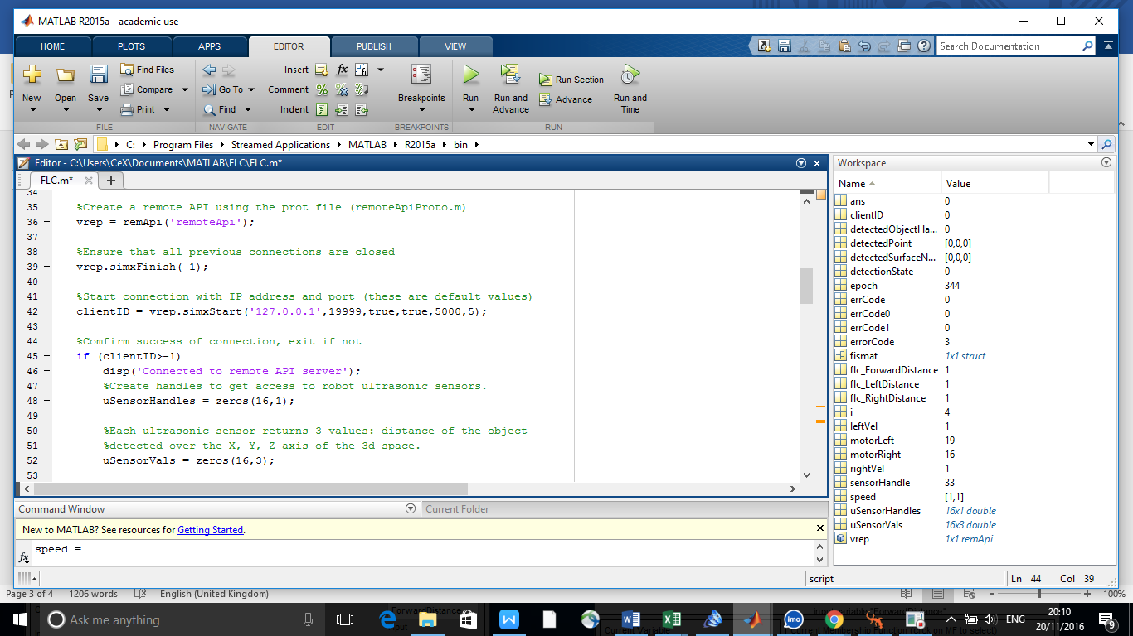
Figure 1. Matlab Code for V-REP Simulation

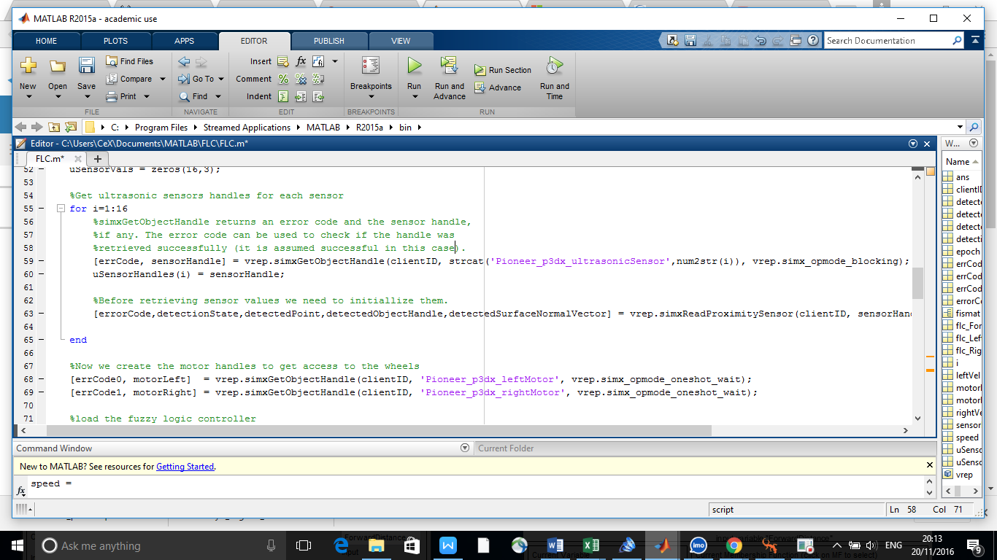
Figure 2. Matlab Code for VREP Simulation
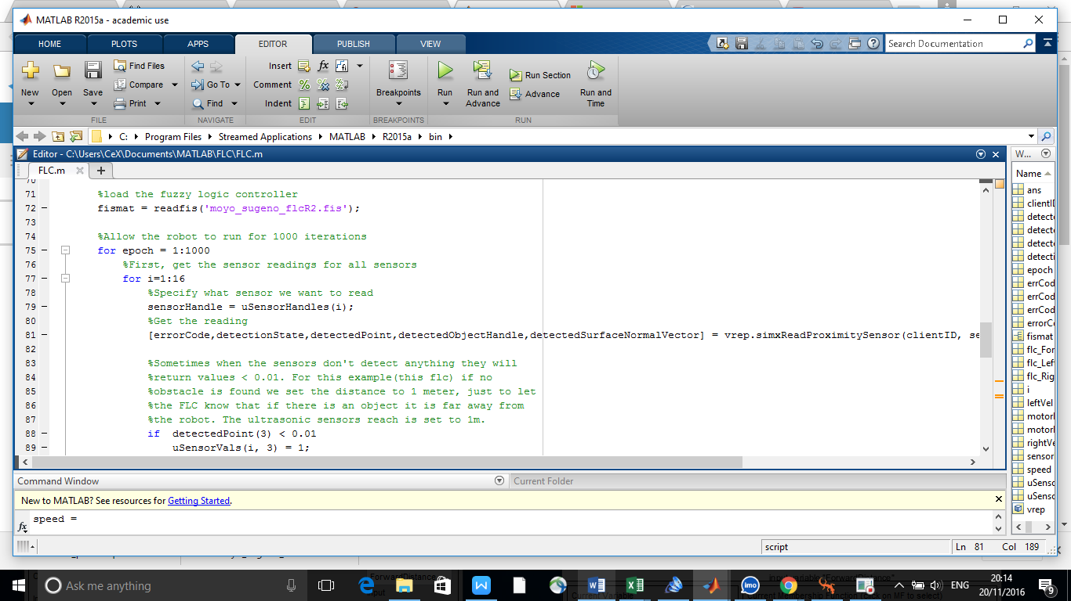
Figure 3. MAtlab Code for VREP Simulation

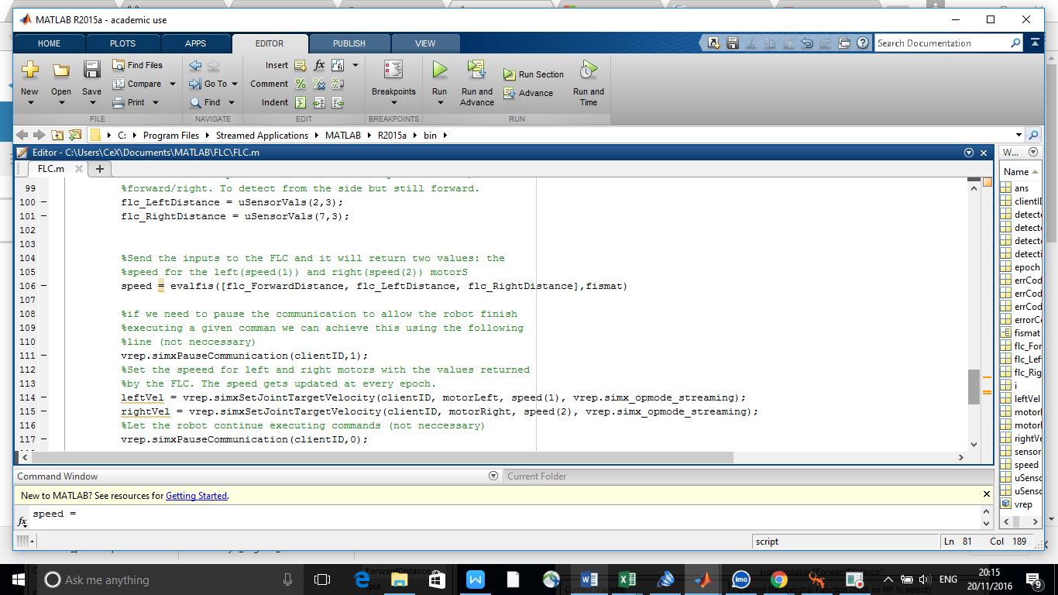
Figure 4. Matlab Code for VREP Simulation
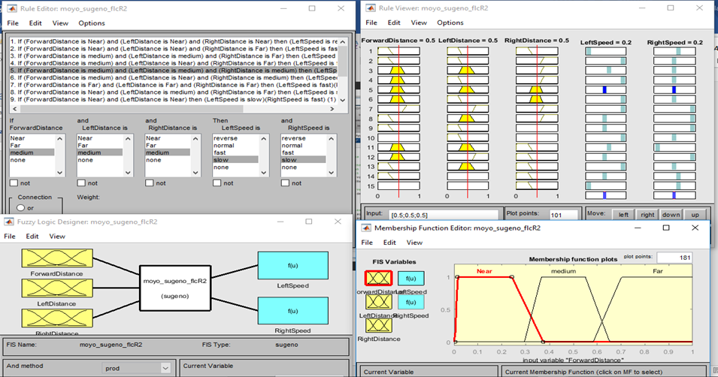
Figure 5. GUI Interface for Matlab Fuzzy Toolbox
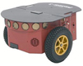
The robot used for the simulation of this work in V-REP is the Pioneer_p3dx. It is equipped with two 19cm wheels, 16 ultrasonic sensors and sophisticated programmable motion controllers.
However, only four proximity sensors will be activated and used in this work. This is to guide against overlapping of sensor readings and aid debugging of experimental errors. The readings of the two foremost proximity sensors will be combined to serve as one sensor while the left and right proximity sensors will also be in use.
Figure 6. Pioneer P3dx Robot
The V-Rep scene is setup with a plain checkerboard surface, scattered cuboids which represent the obstacles and the mobile robot.
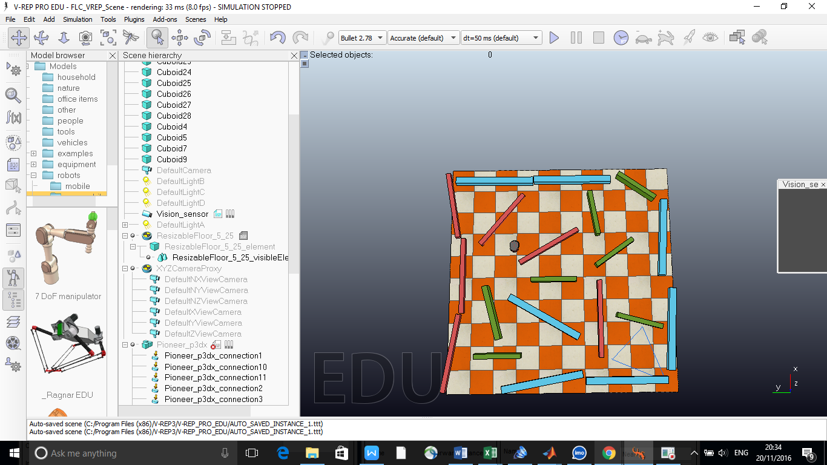
Figure 7. V-REP Scene showing robot and obstacle-filled environment
The scene is played in V-Rep and the control mechanism is then activated by running the program in MATLAB. The robot is seen to manoeuvre its way amidst the obstacles to achieve the aim of movement in a collision free path. A video demonstrating the success of robot’s movement is available in the link below:
https://youtu.be/CbR8WOXs6zU
The inputs to the controller are:
the Front Distance (FD) – which is the distance between the front sensor of the robot and the obstacle
the Left Distance (LD) which is the distance between the left sensor of the robot and the obstacle
the right Distance (RD) – which is the distance between the right sensor of the robot and the obstacle.
The outputs of the controller are the left speed (LS) and right speed (RS) of the left and right wheel respectively.
The linguistic variables used for the three inputs are the same. N: Near, M: Medium and F: Far
L FD = L LD = L RD = [N, M, F]
The linguistic variables for the two outputs are, Reverse, Slow, Normal and Fast.
L LS = L RS = [Reverse, Slow, Normal, Fast]
Each input has three membership functions as show below while the outputs are four constants being a Sugeno type inference.
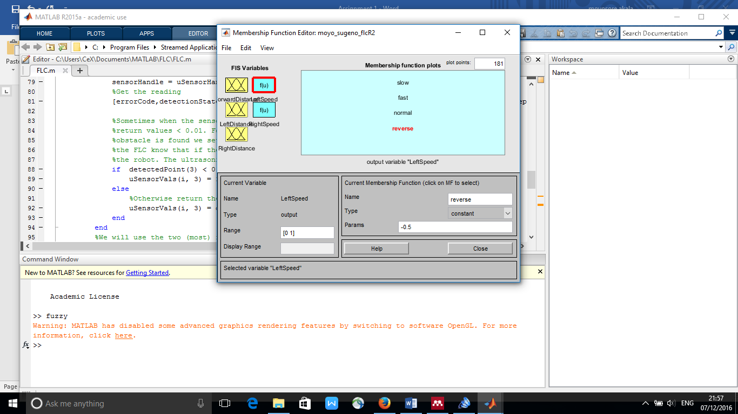
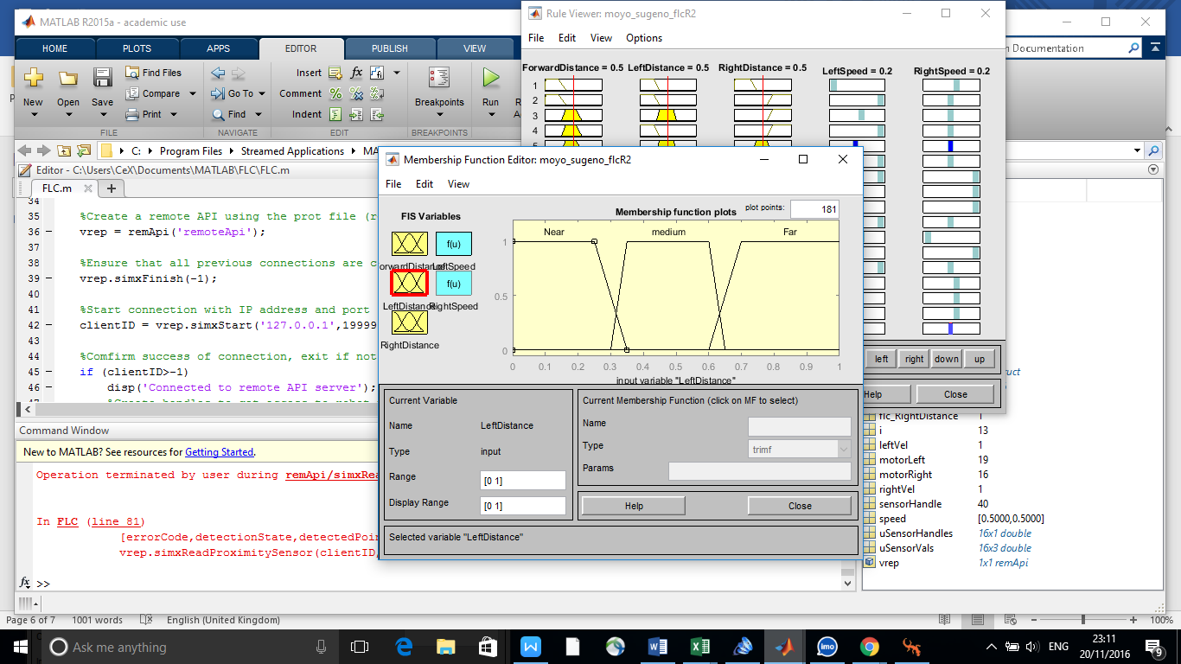
Figure 8. Input membership functions Figure 9. Output membership functions

DESIGN JUSTIFICATION
The Sugeno type inference is chosen over the Mandani-type in designing the fuzzy controller due to its computational efficiency and constant output which is suitable in controlling the robot. Mamdani-type FIS (Fuzzy Inference System) is not as flexible as the Sugeno-type in system design as the latter can be integrated alongside the ANFIS (Adaptive Neural-Fuzzy Inference System) tool to optimize the outputs.
Three membership functions were chosen for each distance input. The values for the function which range between 0 and 1 were chosen to represent a realistic distance of 1meter (max) between a real robot and an obstacle. Each function possesses relatively equal range of values with ‘Near’ being the closest (0m to 0.35m) and ‘Far’ is the farthest.
The outputs are constant values representing the speed of each wheel when a particular rule is fired. Reverse = -0.5, Slow = 0.3, Normal = 0.5, Fast = 1. The range for this value was chosen based on the reaction of the robot during testing.
A total of 17 rules is applied to the controller to guide the robot in a collision free-path during its motion as shown in the table below. The rules were applied in a step-wise manner with a careful observation of the robot’s reaction to a rule before applying another rule.
S/N | INPUT |  |  | OUTPUT
 | FD | LD | RD | LS | RS
1 | N | N | N | Reverse | Normal
2 | N | N | F | Fast | Normal
3 | M | M | F | Normal | Slow
4 | M | N | F | Fast | Slow
5 | M | M | M | Slow | Slow
6 | M | N | M | Fast | Slow
7 | F | F | F | Fast | Fast
8 | N | M | F | Slow | Fast
9 | N | N | - | Slow | Fast
10 | - | N | - | Normal | Slow
11 | M | M | N | Normal | Reverse
12 | M | F | N | Slow | Fast
13 | N | M | N | Fast | Slow
14 | N | - | N | Slow | Normal
15 | - | - | N | Reverse | Normal
16 | N | - | - | Reverse | Normal
Table 1. Fuzzy Rules for Mobile Robot FLC
The defuzzification method used is the weighted average method. This method is valid for symmetrical output membership functions. It is formed by weighting each functions in the output by its respective maximum membership value. The computed solution by MATLAB is LS = 0.2 and RS = 0.2

ANALYSIS OF CONTROLLER PERFORMANCE
The mobile robot travelled for 2 mins in the given environment covering approximately 2 mins. Occasionally, the speed is reduced when there is no forward sight of an obstacle. It was however able to maintain substantial distance away from any of the obstacles and completely avoiding collision. It is seen to reduce its speed when making turns and navigating bends which is key in obstacle avoidance.
At the instance below, when forward distance is far at 0.84, left distance is far at 0.746 and right distance is far at 0.72, both output variables, left speed and right speed at fast at 1. This is a resultant effect of the rule (figure 10) being fired.
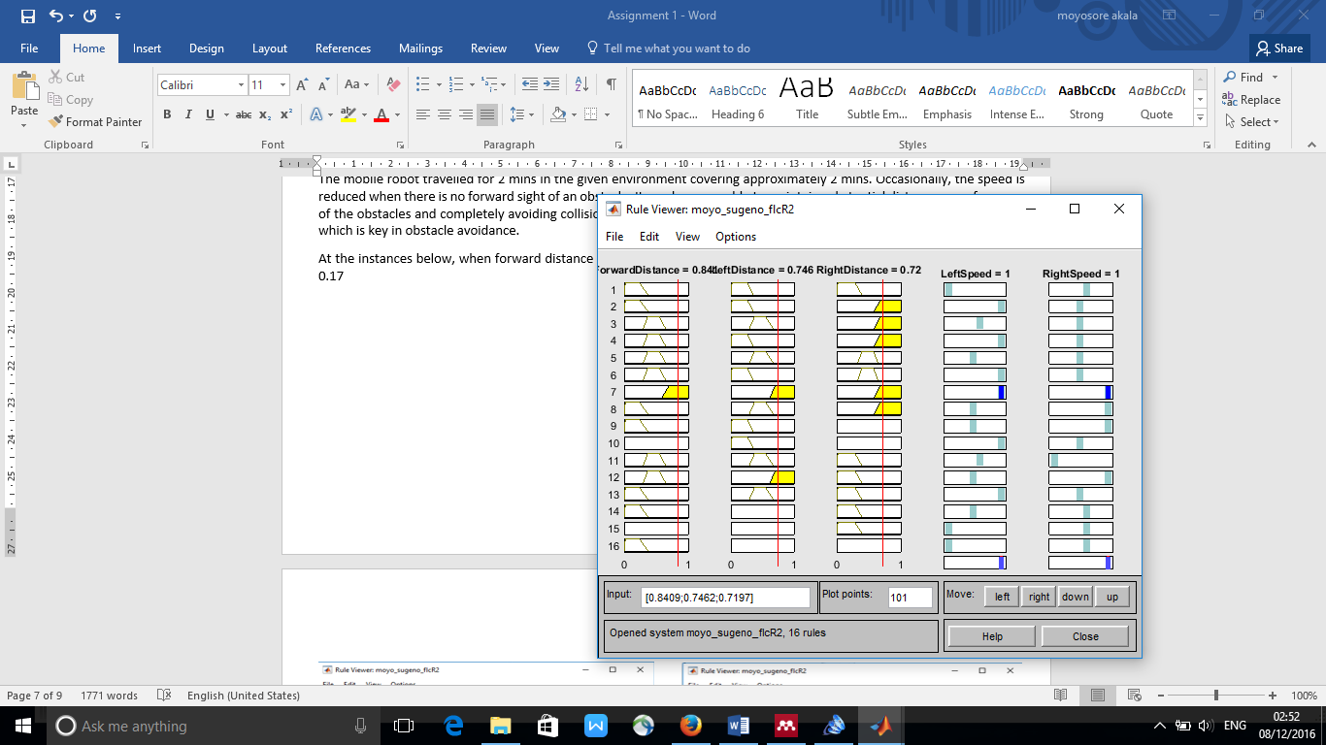
Figure 10. Example of rules being fired at specific instance
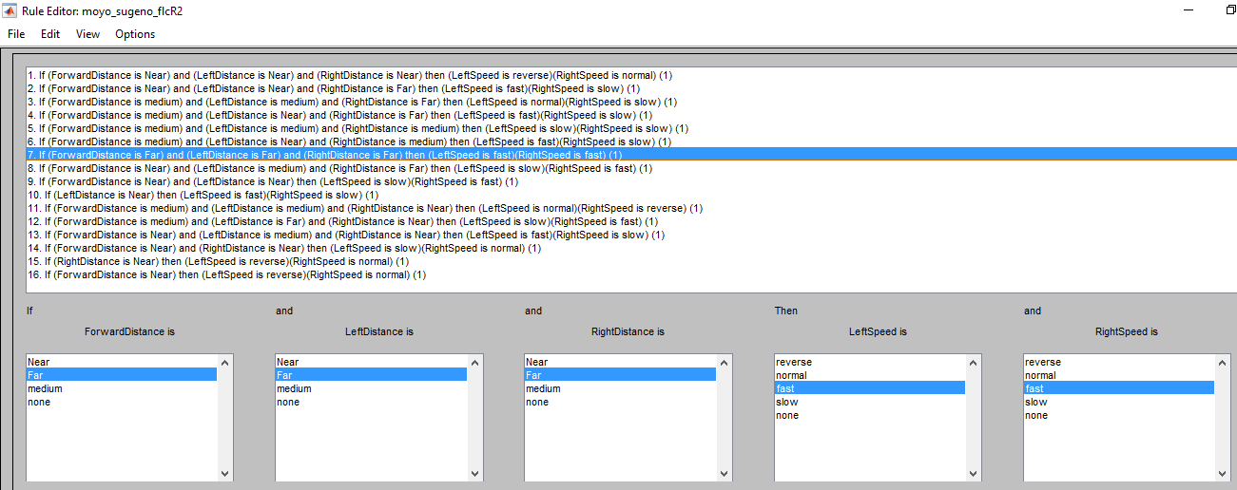
Figure 11. Highlighted rule to control robot movement

From the graph in Figure 12 and 13 below, it is seen that when left distance is near at 0.3 and front distance is medium at 0.4, the right speed is 0.25 while left speed is at 1. This allows the robot bend to the right hand side thus avoiding the obstacle on the left.

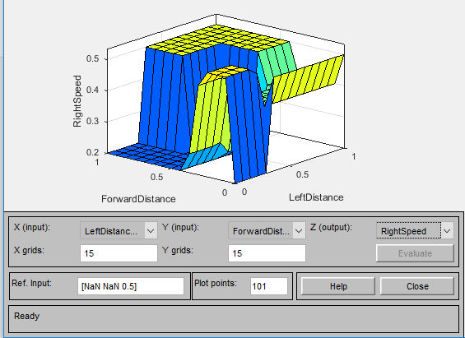
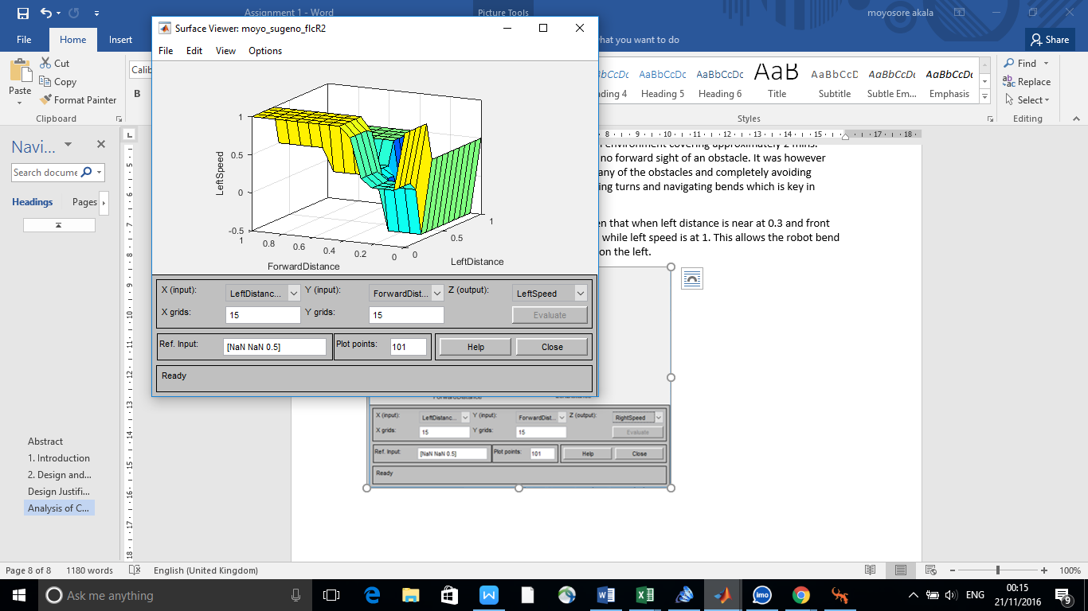
Figure 12. Figure 13.
Graphical representation of inputs and output variable

As shown in the video, the robot continues to find available paths when surrounded by obstacles. The compactness of the robot aids maneuvering with a total of 10 obstacles being avoided in 2 minutes. This suggests that the Pioneer_p3dx will perform a smooth collision-free motion if deployed to a living room with static obstacles.

HYBRID SYSTEMS – FLCS AND OTHER COMPUTATIONAL INTELLIGENCE TECHNIQUES
Hybrid Systems are combinations of two separate systems or techniques to produce a more efficient and optimal solution. The product of the combination usually takes advantage of each technique’s merit and decreases the limitation of their demerits. An example of such hybrid system is a Neuro-Fuzzy system which combines neural network and fuzzy logic into one model. Neural networks are well suited for learning and adaptive tasks (Jacobsen, 1998) but difficult to understand the modalities of its operation. On the other hand, fuzzy logic controllers are well suited for incorporation and interpretation of knowledge but limited in learning and adaptation.
Another illustration of the hybrid system is discussed in [6] where a genetic – fuzzy system was used in generation the optimal path and gait of a robot. Genetic Algorithm which operates based on the mechanics of natural genetics (Pratihar, Deb, & Ghosh, 1999) was used to enhance the performance of a fuzzy logic controller. The genetic-fuzzy system out-performed the ordinary fuzzy logic system in generating stable gaits for the hexapod by optimizing the fuzzy rules.

REFERENCES
- Faisal, M., Hedjar, R., Al Sulaiman, M., & Al-Mutib, K. (2013). Fuzzy logic navigation and obstacle avoidance by a mobile robot in an unknown dynamic environment. International Journal of Advanced Robotic Systems, 10, 10–15. https://doi.org/10.5772/54427
- Iancu, I. (2012). A Mamdani Type Fuzzy Logic Controller. Rijeka: INTECH Open Access Publisher, 330–350. Retrieved from http://www.intechopen.com/books/fuzzy-logic-controls-concepts-theories-and-applications/a-mamdani-type- fuzzy-logic-controller
- MathWorks. (n.d.). Geting started with fuzzy logic toolbox. Retrieved from https://uk.mathworks.com/videos/getting-started-with-fuzzy-logic-toolbox-part-3-68766.html
- Moore, B. L., Pyeatt, L. D., & Doufas, A. G. (2009). Fuzzy control for closed-loop, patient-specific hypnosis in intraoperative patients: A simulation study. Proceedings of the 31st Annual International Conference of the IEEE Engineering in Medicine and Biology Society: Engineering the Future of Biomedicine, EMBC 2009. https://doi.org/10.1109/IEMBS.2009.5332539
- Jacobsen, H. a. (1998). A generic architecture for hybrid intelligent systems. 1998 IEEE International Conference on Fuzzy Systems Proceedings IEEE World Congress on Computational Intelligence Cat No98CH36228, 1, 709–714. https://doi.org/10.1109/FUZZY.1998.687575
- Pratihar, D. K., Deb, K., & Ghosh, A. (1999). Design of a Genetic-Fuzzy System for Planning Optimal Path and Gait Simultaneously of a Six-legged Robot. Proc. of the {G}enetic and {E}volutionary {C}omputation {C}onf. {GECCO}-99, 1678–1684.
- Auriel, R. G. (2016). Sample Program that creates a remote API Server to allow the running of Matlab Code with V-Rep Software. M28COM Evolutionary and Fuzzy System in Coventry University.

